|  |  |
| --- | --- |
| Assessment Title | Assignment 2 – Configure the cloud services |

## Competency Details

|  |  |
| --- | --- |
| Unit code/s and title/s | ICTCLD401 - Configure cloud services (Release 1) |
| Qualification code/s and title/s | National Code: ICT40120 Certificate IV in Information Technology |
| Business unit/Workgroup | Business and Arts / IT Studies |

## Instructions

|  |  |
| --- | --- |
| Method/s of assessment | Product and Questioning (Written) |
| Overview of assessment | This assessment will require you to demonstrate your ability to setup and config AWS cloud services as required, seeking feedback, and summary documentation. |
| Task/s to be assessed | This assessment will require you to complete the practical tasks to set up cloud services:   * Task 1: List functions, benefits and differences of cloud services * Task 2: Implement Cloud User * Task 3: Create AWS Virtual Network and Security settings * Task 4: Deployment of automatic scaling * Task 5: Complete project documentation and seek feedback. * Task 6: Respond to feedback   Students will also complete written answers to questions on the topics above. |
| Time allowed | Refer to your schedule for submission dates |
| Location of assessment | Assessment can be completed anywhere with access to the resources required. (See Resources Required section below) |
| Decision making rules | To receive a satisfactory outcome for this assessment you must complete all parts correctly.  Word counts are provided as guidance only. |
| Assessment conditions | This assessment must be undertaken where the conditions replicate noise levels and interruptions that people typically experience working in the ICT industry.  This is an unsupervised assessment and you may access any required resources.  This is not group work and must be completed as an individual. |
| Resources required | To complete this assessment, you will require the following:   * Access to Learn with Internet access * Learn resources * Word processing software such as Microsoft Word. * AWS account to be able to perform the tasks * AWS learning site to perform the tasks * ICTCLD401 - ASDS - Organisational Requirement.docx |
| Result notification and reassessment information | You will be provided feedback and the result for your assignment on TAFE SA Learn. You will be and given the chance to resubmit with the required corrections only once.  Refer to the TAFE SA assessment policy for more information <https://www.tafesa.edu.au/apply-enrol/before-starting/student-policies/assessment> |

**Scenario**: Erfys Confection is pleased with your research and analysis of their current cloud requirements (Assignment 1). To fully commit to the cloud migration the board members would like to see a working proof of concept. Perform the following tasks to demonstrate the benefits of cloud adoption.

## Task 1: List functions, benefits and differences of cloud services

After comparing the functions and benefits, list your recommended AWS services based on Erfys Confectionary’s cloud service requirement and justify with reasons?

* Vertical scaling or horizontal scaling
* Virtual machines or Physical machines
* Relational database or data warehouse or no SQL databases
* self-hosted or managed or cloud-native database solutions
* Block storage and object storage
* archive storage and network filesystems storage

Answer：

|  |  |  |  |
| --- | --- | --- | --- |
|  | Adopted option(s) | AWS Services Choice Recommendation | Justification |
| a. Vertical scaling or horizontal scaling | horizontal scaling | AWS Auto Scaling, Amazon EC2 | Horizontal scaling is chosen over vertical scaling because it allows for adding more instances instead of upgrading a single instance, which is more flexible and cost-effective. This is crucial for Erfys' requirement of high availability and scalability. |
| b. Virtual machines or Physical machines | Virtual machines | Amazon EC2 | Virtual machines (VMs) are selected over physical machines because they offer greater flexibility, are easier to manage, and can be provisioned or decommissioned quickly, aligning with Erfys' need for rapid scalability and cost minimization. |
| c. Relational database, data warehouse, or no SQL databases | Relational database | Amazon RDS | A relational database is chosen over data warehouses or NoSQL because Erfys needs to manage structured transactional data, such as orders and customer information, that relies on predefined relationships. Amazon RDS is well-suited for this, offering automated backups, scaling, and redundancy. |
| d. Self-hosted, or Managed or Cloud-native database solutions | Managed Database | Amazon RDS | Managed database solutions are preferred over self-hosted or cloud-native options because they reduce Erfys' need for in-house IT support and management overhead. |
| e. Block storage and object storage | Object Storage | Amazon S3 | Block Storage is used for low-latency, high-performance applications like databases, providing fast access to data. Object Storage is best suited for scalable and cost-efficient storage of unstructured data, such as backups, media, and documents. This meets Erfys' need for scalability, flexibility, and high availability of content and documents, while also ensuring high-performance storage for critical applications like databases. |
| f. archive storage and network filesystems storage | Archive Storage & Network Filesystems Storage | Amazon S3 Glacier, Amazon EFS | Archive Storage is ideal for low-cost long-term storage of rarely accessed data (such as backups), while Network Filesystems provides shared file access with metadata, essential for collaboration across teams. |

Task 2: Implement Cloud User

## Accounts and restricted access

Below are the tasks you need to implement on your AWS account or LMS environment. For each step, you are required to provide a screenshot of each task.

Following the organisational requirements (File: ICTCLD401 - ASDS - Organisational Requirement.docx), complete the following tasks:

* 1. Create all the users listed in appendix A that require cloud access.
  2. Create groups suitable for achieving the requirements identified in the Security requirements section of the Organisational requirements.
* Use your student ID in front of the group name and username, for example, 000123456-CEO as the CEO group name.
  1. Assign permissions according to the Security requirements and Business protocols sections of the Organisational requirements.
  2. Update password policy
  3. Test user access and multi-factor authentication by logging into AWS web services with the CEO’s account.

Insert screenshots below:

* All created users with the group assigned.
* CEO & Sales manager accounts are to be logged in with the management console
* Groups with security permissions assigned.
* AWS Password Policy Screenshot
* Multi-factor authentication login screenshot (R&D manager)
* Use the AWS command Tool to list all your created users

## Task 3: Create AWS Virtual Network and Security settings

As a proof of concept before migration, your manager would like to see a simulated environment to test all functions and features.

1. Implement a multi-tiered network capable of supporting auto-scaling. See the network diagram below (fig.2):
   * Use the following network address:
     1. 10.**X**.0.0/16 to set up your virtual cloud network.
     2. Use your year of birth as **X**, e.g., 1995 X=.95

fig.2

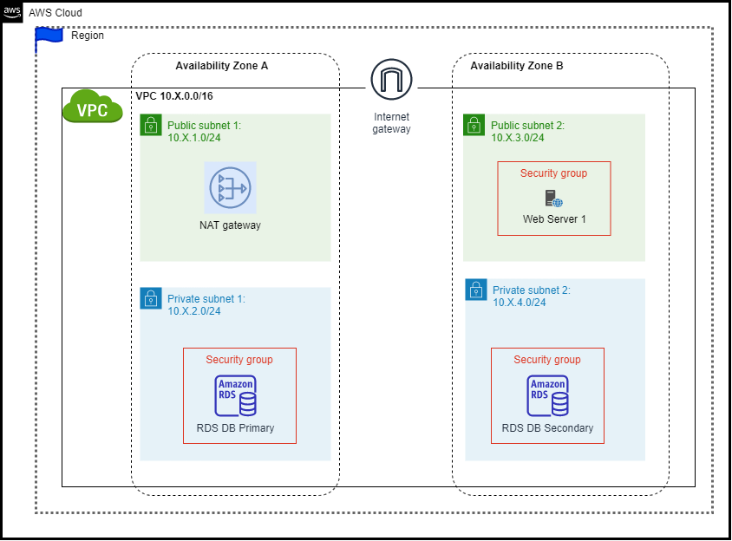

1. Create a multi-tiered virtual network according to the business requirements to support cores services and auto-scaling. (ICTCLD401 - ASDS - Organisational Requirement.docx)

You need to:

* Set up a VPC (Virtual Private Cloud) network (your name’s initial@ ErfylVPC) and creates related subnets.
* Create one virtual network and inside the network create 2 public and 2 private networks.
* Assign Public/Private subnets to the related routing table associations based on requirements.
* Create a security group that only allows HTTP, HTTPS and SSH to access the public network.

Insert the screenshots for the below Subnet Reference Table (replace X with the number provided previously)

|  |  |  |  |  |
| --- | --- | --- | --- | --- |
| Subnet Name | IP Address Range | Availability Zone | Routing Table screenshot | Subnet screenshot |
| ErfylVPC | 10.**X**.0.0/16 | N/A | N/A |  |
| Public Subnet 1 | 10.**X**.1.0/24 | [Area]-[Location]-[Number]a (for example, us-west-2a) |  |  |
| Private Subnet 1 | 10.**X**.2.0/24 | Same as above |  |  |
| Public Subnet 2 | 10.**X**.3.0/24 | [Area]-[Location]-[Number]b (for example, us-west-2b) |  |  |
| Private Subnet 2 | 10.**X**.4.0/24 | Same as above |  |  |

* Insert a screenshot showing the security group.
* Insert the screenshot of routes for all your routing tables

1. Create virtual machines:

For test purposes, the ITWorks manager needs you to set up a virtual server according to the business requirements (Cloud service requirements section).

Configure the following:

* Public IP address (obtained from AWS)
* The VM as an HTTP server in your public **Zone B** with the below loading script:

------------------

#!/bin/bash -ex

# Updated to use Amazon Linux 2023

dnf update -y

dnf install -y httpd wget php-fpm php-mysqli php-json php php-devel

dnf install -y mariadb105-server

/usr/bin/systemctl enable httpd

/usr/bin/systemctl start httpd

cd /var/www/html

wget https://aws-tc-largeobjects.s3.amazonaws.com/CUR-TF-100-ACCLFO-2/lab5-rds/lab-app-php7.zip

unzip lab-app-php7.zip -d /var/www/html/

chown apache:root /var/www/html/rds.conf.php

---------------------

* Setup virtual network security rules to only allow HTTP, HTTPS and SSH traffic to public subnets.
* Test your HTTP access from your home/class PC and take screenshots.

Insert your screenshots below:

EC2 console with public IP address and availability zone

Security Groups with rules allow HTTP, HTTPS & SSH

Successful web access page from your computer

1. Add additional storage and make storage expandable.

Erfys Confectionary wish to test storage functionality.

Conduct the below tasks:

* 1. Create an Amazon EBS volume with your name initials
  2. Attach and mount your volume to an EC2 instance
  3. Increase the EBS storage size from 1 GB to 10 GB

Insert the following screenshots:

* EBS page
* EC2 instance page with storage attached
* EBS storage page before and after the change
* DF –h results in Linux CLI

1. Erfys Confectionary wish to implement a highly available database. Perform the following tasks:
   1. Launch an Amazon RDS DB instance with high availability across 2 different availability zones.
   2. Configure the DB instance to permit connections from your web server.
2. Open a web application and link to your database, then update the information.
3. Configure the RDS backup retention period to 14 days

Insert the following screenshots:

* Network DB security group.
* Database Subnet Group
* Database creation
* The website successfully connects to Database (Showing the address book) Add your name information to the address book, other information can be random.
* Database retention period is set up as 14 days

## Task 4: Deployment of automatic scaling

In this task, you need to configure and apply auto-scaling to the virtual machine according to the Cloud requirements section of the organisational requirements. Once it is configured, you need to test and fix errors faced in the autoscaling.

1. To complete this activity, you need to do the tasks below:

* Create an Amazon Machine Image (AMI) from a running instance.
* Create a load balancer.
* Create a launch configuration and an Auto Scaling group.
* Automatically scale new instances within a private subnet
* Create Amazon one CloudWatch target tracking policy and monitor the performance of your infrastructure.
* Enable the CPU load of your VM and check that 2 to 5 instances are created.
* Test autoscaling and fix errors

Final stage diagram Fg3:

Fg3.

Insert your screenshot for each request below:

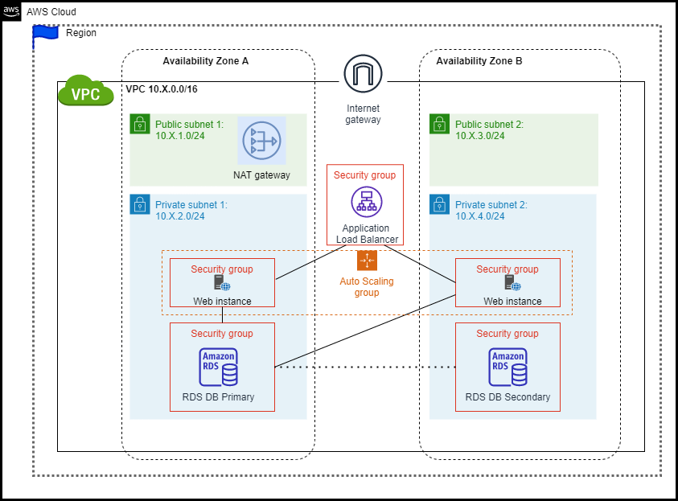

Insert your screenshot for each request below:

* Created AMI image
* Load balance status page with DNS name
* Launch template page
* Auto scaling groups detail page
* Target Tracking policy page
* Open Load balance DNS name in the browser
* Enable CPU load
* CloudWatch In alarm state after loading CPU on the webpage
* At least 4 instances created on Auto scaling groups instance management page

1. Complete the troubleshooting task:

Erfys Confectionary is in the process of creating a new test environment for auto-scaling. They aim to establish a VPC that includes a publicly accessible web server with the following features:

* Public access through HTTP
* Autoscaling with a minimum of 1 instance, desired 2 instances, and a maximum of 3 instances.
* An autoscaling policy that adjusts to a minimum of 2 instances, desired 3 instances, and a maximum of 4 instances at 9:00-11:00 AM daily.

Unfortunately, they have encountered some problems after setting up the cloud workloads, such as an inability to access the web server and malfunctioning of the autoscaling feature. You are asked to provide support in resolving these issues.

You need login Learner Lab on the AWS Academic website, and run the below commands to setup the troubleshooting environment:

git clone https://github.com/jlcloudtea/AWSFSTroubleshooting TRscript

cd TRscript

bash run.sh

After selecting option 1 as shown on the screen, wait for 2 to 5 minutes until the system displays "completed." At that point, you can proceed to the AWS console page to begin troubleshooting.

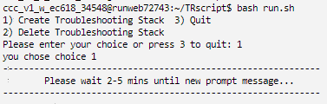

After you finish the troubleshooting, complete the below troubleshooting table and provide screenshots as evidence.

|  |  |  |
| --- | --- | --- |
| Problems | Description (Cause) | Fix solution |
| 1. Cannot access HTTP server (2 problems) | 1.  2. | 1.  2. |
| 1. Autoscaling not working properly (2 problems) | 1.  2. | 1.  2. |

Provide Fix screenshots:

Problem 1-1:

Problem 1-2:

Problem 2-1:

Problem 2-1:

## Task 5: Complete project documentation and seek feedback.

1. You are required to complete the following summary tasks:

* Erfys Confectionary users require some instruction to perform some of the more complicated tasks. Create user documentation with instructions on how to create a new EC2 instance.
  + Include step-by-step instructions
  + Include screenshots to help the user
  + Use easy-to-read language
* Store all documents according to the Organisational documentation storage procedures section of the Organisation requirements document (ICTCLD401 - ASDS - Organisational Requirement.docx).

1. After you have submitted the document, you are required to:

* Compose an email to the ITWorks manager (Lecturer). Do not send it but save and submit this email to LEARN.
* The email should include the following. (Approximately 50 words)
* Inform the ITWorks manager that the user documentation has been submitted
* Insert a screenshot of the submitted document of AWS S3
* Seek feedback from the ITWorks manager
  + - Of your performance.
    - Any additional tasks or requirements.

**Instruction for upload:**

Please ensure the following is done when you submit your work:

1. Upload it to the TAFE SA moodle. Ensure that you’ve named your file(s) according to the following: subject__assessment_lastname.doc (ie. CLD401_Assignment_Evans.doc)
2. Upload must include:
   1. This document (Tasks 1-4).
   2. The user documentation (from Task 5).
3. Lecturer preference may vary but students should only submit one file that contains all of their work. This saves time and the need to open and modify multiple documents. The layout of the document should be as follows:

* Cover Sheet with your name and student Id
* Use this document and place your evidence in the appropriate sections.

1. If you’re still unsure about what/how to submit your assignment, consult your lecturer.

## Task 6 Respond to feedback

Complete the additional tasks sent by your client.

Compose an email message in response, including the following:

* Screenshot of your completed tasks
  + Public link to your document
* Insert this public link in text (not screenshot) and access screenshot evidence (Browser in private mode) here.

**Instruction for upload:**

Please ensure the following is done when you submit your work:

1. Upload it to the TAFE SA moodle. Ensure that you’ve named your file(s) according to the following: subject__assessment_lastname.doc (ie. CLD401_Assignment_Evans.doc)
2. Upload must include:
   1. This document (Tasks 6).
3. Lecturer preference may vary but students should only submit one file that contains all of their work. This saves time and the need to open and modify multiple documents. The layout of the document should be as follows:

* Cover Sheet with your name and student Id
* Use the this document and place your evidence in the appropriate sections.

1. If you’re still unsure about what/how to submit your assignment, consult your lecturer.